The following tree is used in the sample output below.

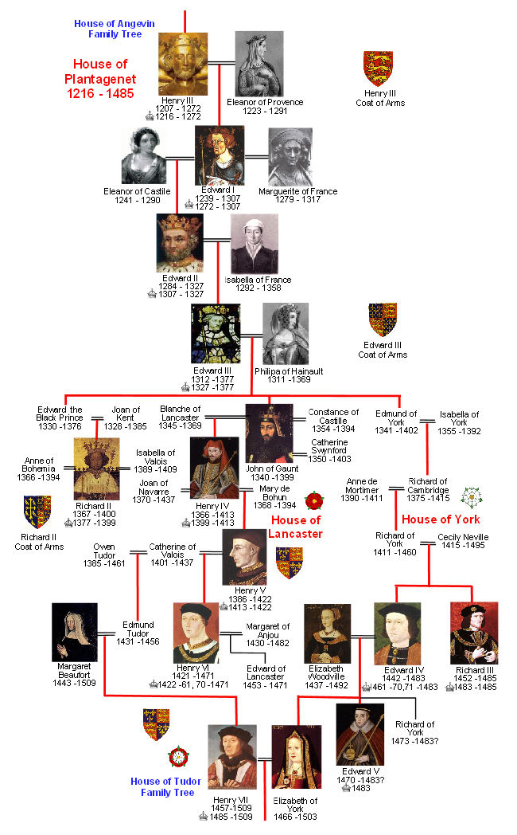

What would you like to do next? add

what is the name of the human? Henry III

What would you like to do next? add

what is the name of the human? Eleanor of Provence

What would you like to do next? add

what is the name of the human? Eleanor of Castille

What would you like to do next? add

what is the name of the human? Edward I

What would you like to do next? relate

what is the name of the parent human? Henry III

what is the name of the child human? Edward I

What would you like to do next? add

what is the name of the human? Edward II

What would you like to do next? relate

what is the name of the parent human? Edward I

what is the name of the child human? Edward II

What would you like to do next? relate

what is the name of the parent human? Eleanor of Castille

what is the name of the child human? Edward II

What would you like to do next? get grandparents

what is the name of the human? Edward II

The grandparents are: Henry III

What would you like to do next? relate

what is the name of the parent human? Eleanor of Provence

what is the name of the child human? Edward I

What would you like to do next? get grandparents

what is the name of the human? Edward II

The grandparents are: Henry III Eleanor of Provence

What would you like to do next? add

what is the name of the human? Edward III

What would you like to do next? add

what is the name of the human? Philipa of Hainault

What would you like to do next? relate

what is the name of the parent human? Edward II

what is the name of the child human? Edward III

What would you like to do next? save tree

what is the file name to save? plantagenet.json

Tree saved.

What would you like to do next? quit

What would you like to do next? load tree

what is the file name to load? plantagenet_3.json

[ Reset vs add removed ]

Tree loaded.

What would you like to do next? get descendants

what is the name of starting human? Henry III

what is the degree of descent? 4

The level 4 descendants of Henry III are: Edward the Black Prince John of Gaunt

What would you like to do next? get ancestors

what is the name of starting human? Edward the Black Prince

what is the degree of ancestors? 4

The level 4 descendants are of Edward the Black Prince are: Henry III Eleanor of Provence

What would you like to do next? quit